**Demarcating Crime Regions in Urban Areas using Gaussian Mixture Models**

*Japneet S. Kohli*

*Department of Information Sciences and Technology*

*George Mason University*

*Fairfax, USA*

*jkohli2@gmu.edu*

*Mahdi Hashemi*

*Department of Information Sciences and Technology*

*George Mason University*

*Fairfax, USA*

*mhashem2@gmu.edu*

**Abstract**

*Crime fighting agencies all across the world record the work that they do and create and store detailed reports of all crime related activities. With the expansion of technology, it is becoming easier for the public to access this data as more and more such data is stored and shared digitally. This can be useful for extracting patterns and meanings related to crime. Various studies in the past have ventured to find these relationships in crime data. This study also endeavors to make such an attempt using publicly available data regarding crimes in New York city. The purpose of this study is to examine the crime patterns in the city of New York using Gaussian mixture models in order to demarcate areas based on propensity for various types of crimes examined. An approach exploring heuristically classified violence regions is also presented. This study endeavors to better identify areas in a city where certain types of crimes occur more frequently and offer a better understanding of the nature of criminal activities. This study is restricted by the rarity of data related to violence available in terms of city-wide crime statistics. Availability of this data can allow this study to develop more intricately with the ground truth.*

Keywords: Gaussian Mixture Models, Machine Learning, Crime, Violence, Akaike Information Criterion, Bayesian Information Criterion, Clustering, Supervised Learning, Unsupervised Learning

**1. Introduction**

Cities such as New York, Washington, D.C., and Chicago, IL, have opened large chunks of their city-wide data to the public. Such data can be found at platforms such as NYC Open Data or Open Data DC. The availability of this data has made it easier than ever before to conduct analyses and find meaning in the various domains of public life for which data is made available by these cities.

Some of the data on such platforms is released by agencies involved with public safety, such as Police departments. Inherently, therefore, this data includes attributes related to public safety, which is often measured in terms of crimes recorded. This data can be analyzed to tell the story of crime in urban areas. This study intends to tell a story about the different types of crimes committed in different parts of New York city. The intention is to help create a crime region demarcation methodology that can be replicated for other cities as well.

To best encapsulate the story of crime in New York city, a novel approach has been suggested in this study that attempts to identity areas with varying levels of violent criminal activities. This identification is made using heuristics pertaining to the widely-accepted legal expertise regarding which types of crimes have propensity for violence. Since the data at hand does not directly record this aspect of crimes, an assessment in this regard has to be made, somewhat subjectively. This restricts the universality of the study as such assessment cannot be objective without changing how the data for the crimes is collected in the first place.

After the violence indicator identification is made, each crime record is assigned membership in a cluster indicating level of violence. These clusters are created using an algorithm that utilizes Gaussian Mixture Models (GMM). GMM are a way to improve upon the results of k-means clustering. K-means clustering is hard-clustering, meaning each item in the data can only be assigned to one cluster. On the other hand, GMM incorporate a soft-clustering, probabilistic-model based approach for distributing the points in a cluster [1].

In addition to the above supervised learning-based classification approach, a second approach to identify crime regions in New York city is also applied. This is an unsupervised learning approach that uses GMM based algorithms to identify spatial clusters in specific datasets. The datasets are determined by an analysis of the types or categories of crimes that seem to depict certain interesting patterns in New York city. Clustering of crime data identified in this manner is a good indication of the spatial regions in New York city based on crime.

The outcome of both the approaches can best be described through visual aids. Therefore, appropriate visualizations to best represent the demarcations of various crime regions in the city are also presented.

**2. Related works**

A probabilistic model that assumes that all the data points in it are generated from a mixture of a finite number of Gaussian distributions with unknown parameters is known as a GMM [1]. There have been several studies that have attempted to discern patterns in data and provide new applications using GMM. Instances of creating novel GMM are also prevalent.

In a case-study about identifying curbside parking demand, Tanner Fiez and Lillian Ratliff proposed a method for making such identifications using GMM. They used it as an unsupervised clustering method in order to assist them with finding zones and groups representing areas that are spatially nearby and have similar parking demand. The work can possibly allow progressively educated decision-making, through which both policy-related choices as well as design-planning can benefit through the focused use of data and incentives borne out of them [2].

GMM have also been constructed to enhance the memory storage capabilities of systems. One such mechanism is proposed in the form of a new, spinning tri-layer-circle memory based GMM (STLCM-GMM) [3]. In this mechanism, pixels and Gaussian distributions are stored and processed in the three circle memory spaces. This model proposes that it can recall all the previous states of a given image or scene. There are useful applications for such a model in the domain of background modeling [3].

Another novel GMM approach has been proposed to address the challenges of selecting parameters in dynamic machine learning models. The proposed solution attempts to create much lesser impact on the parameter calibration accuracy as has been observed through previous approaches. The approach incorporates Kalman filters based on GMM. The results show that the new approach can help provide parameter selections with better accuracy and calibration for controlled conditions with Gaussian distributions as well as conditions that do not mimic real Gaussian distributions, which is typically the case in real life, extending the utility of this model to a wider net of scenarios [4].

Hierarchical GMM, in combination with traffic phase-transition analysis as well as quantization of entropy in information, have been used to create a framework that can help identify characteristics in highway traffic dynamics. The hierarchy of the GMM is based on dimensionality of the functions, where one- and two-dimensional functions are considered. The former model represents aspects related to time dimension with respect to the traffic flow dynamics, whereas the latter represents both time and location for traffic flows. This framework can be applied to acquire features from traffic via real-time monitoring as well [5].

GMM have also been simplified to reduce the number of mixture components. This has been accomplished by affecting the log-likelihood of sample data points in such a way that the lower bound of the log-likelihood is maximized. This helps reduce the number of mixture components, thereby simplifying the GMM. Simplifying the GMM can help to make the data analysis faster, and was demonstrated to be more accurate too [6].

GMM can also be used to support Gaussian mixture regression, which has applications in industrial processes, especially in quality-related functions. Towards this end, a variation on Gaussian mixture regression, based on GMM but meant for non-Gaussian industrial processes has been developed by Jinlin Zhu, Zhiqiang Ge, and Zhihuan Song. They design a system improves the reliability of a Gaussian mixture regression based soft sensor development mechanism by incorporating a Bayesian modeling method [7].

GMM have an application in the domain of image restoration as well. A novel approach suggests using multivariate GMM to create a framework for image restoration based on the assumption that, within an image, the similar patches are collected in nearby neighborhoods and are derived from Gaussian distributions. By constraining the Gaussian estimates into limited windows sizes for the patches, the researchers were able to determine a better fit for the statistical properties of the patches as compared to Gaussian estimates without any size limits for patch windows. This novel approach can help reconstruct images from recovered patches and is found to be similar to Gaussian clusters. [8]

It is clear that methodologies based on GMM are a popular choice for conducting research and analysis across various domains and fields of expertise. Just as numerous are the applications for these proposed methodologies. In this paper, we will try to incorporate supervised and unsupervised algorithms based on GMM to help determine the clusters to which various instances of crime belong.

On the one hand, the unsupervised GMM algorithm implemented attempts to find clusters specific to a certain type of crime or pattern observed in the criminal data. The supervised GMM algorithm, on the other hand, attempts to classify crime records based on heuristically determined violence labels. Various studies in the past have attempted to describe violence in the society.

Violence can come across in many forms, as is addressed in [9], where a critical review of the various literature regarding universal violence and child maltreatment prevention programs for parents is conducted. In this review, the mechanisms to address violence focus on the various behaviors and outcomes that can determine violence. This tends to be a subjective approach, which is a challenge when dealing with a concept such as violence, the understanding and definition of which can change depending on the context to which it is applied.

As a general guideline, in the Encyclopedia of Psychology, the American Psychological Association defines violence as an extreme form of aggression. This can include acts such as assault, rape, or murder [10]. Such a description of violence, in terms of the acts that can be recorded, can help bring an objective framework for recognizing violence. This is especially relevant in the context of crime analysis.

Identifying and reporting violence in society is an important task for maintaining the rule of law and retain human dignity. As technology has evolved over the years, the efforts to better determine violence in society have also seen an increase.

One such attempt focused on analyzing social media data to recognize instances of domestic violence and abuse. This was accomplished by proposing a deep learning architecture that included convolutional neural networks (CNN), recurrent neural networks (RNN), long-short term memory (LSTM), gated recurrent units (GRU), and bi-directional long-short term memory (BLSTM) models [11].

A critical review of the various techniques and methods proposed for identifying violence through data was conducted in [12]. Ramzan et al. determined the pros and cons of the various state-of-the-art violence detection techniques, including techniques using traditional machine learning, support vector machines (SVM), and deep learning. They felt it important to mention that the quality of classification methods is limited by the quality of the datasets that are used [12].

In defining violence objectively, this study uses the guidelines for determining violence defined by defining them through acts as proposed in [10]. Crime related data that is analyzed in this paper is outlined by the type of crime committed, which is the underlying factor in making this decision.

To summarize, two approaches are attempted in this study, both involving the use of GMM based algorithms. The first approach is a supervised GMM-based methodology that is used to classify crime-related data into classes of violence. The second approach attempts to implement unsupervised GMM-based algorithms on interesting datasets that representing certain types or patterns of crime. The cluster assignments are spatially relevant and can be used to demarcate crime regions in New York city.

**3. Data description**

The data for this study can be obtained from New York City’s Open Data portal. It is derived from the New York Police Department (NYPD) Complaint Map (Year to Date) [13]. This dataset includes all valid felony, misdemeanor, and violation crimes reported to NYPD for all complete quarters in the year 2019. The distribution of these three types of crimes are shown in Figure 1, which highlights that the most common type of crime that is recorded is a misdemeanor, while the least common type of crime is a violation.

Offenses occurring at intersections are represented at the X Coordinate and Y Coordinate of the intersection. Crimes occurring anywhere other than an intersection are geo-located to the middle of the block.

The NYPD Complaint Map data contains 461,711 records. Each record reports one complaint of a crime. Figure 2 shows the various attributes related to these crime records that are found within the dataset.

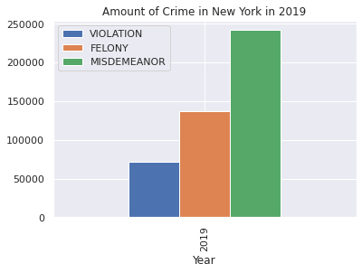

**Figure 1: Crime distribution by law category for New York city in 2019**

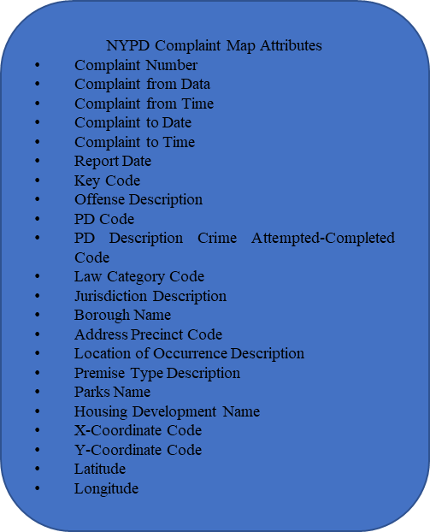

**Figure 2: NYPD complaint map dataset attributes**

Out of the attributes listed in Figure 2, Key Code and PD Code seem especially useful as both the codes classify the type of offense recorded. The PD Code attribute is more granular than the Key Code attribute, which means that it has more classes than Key Code and is more descriptive of the type of crime committed. For reference, there are over 63 different Key Codes that are described within the dataset; in comparison, over 367 PD Codes are listed, which is almost six times as many codes.

The complaint-start date, complaint-end date, and complaint-times are also recorded in the dataset. While the start dates and times are listed for all the crime records, the end dates and times are sparsely populated, which indicates that these records may not be updated with much diligence once the work upon the complaints has been finished.

The dataset also records whether the attempted crime was completed. The level of offense, in terms of the law category codes, that the attempted crime belongs to is also recorded.

As can be observed from Figure 2, several attributes can help spatially locate where the crime occurred. General area indicators are present, such as those coded in the Borough Name and Address Precinct Code attributes. More precise indicators of the area are provided by the four coordinate attributes, namely X-Coordinate Code, Y-Coordinate Code, Latitude, and Longitude.

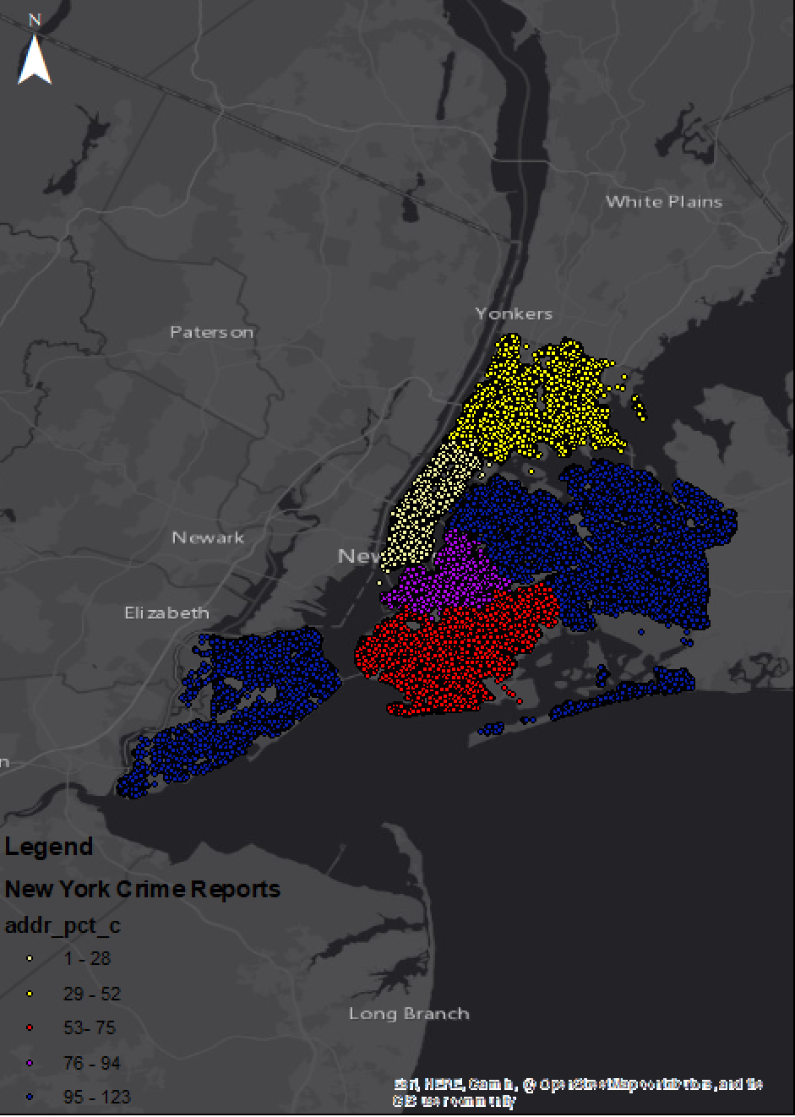

**Figure 3: New York city crime reports by precinct code**

Figure 3 visualizes the crime reports divided by precincts in the city of New York. The precincts are grouped together in the following brackets: 1 to 28; 29 to 52; 53 to 75; 76 to 94; and 95 to 123. Figure 3 makes it clear that the precincts are clustered together geographically, with the only exception being the group 95 to 123, where two separate clusters can be observed, meaning that these precincts are located in two different parts of the city. Figure 3 is also helpful in visualizing the extent of the spatial reach within and near New York city that can be considered by the study.

A determination of level of violence associated with each crime incident can be made using the labels mentioned in the Offense Description attribute, which describes the nature of the crime conducted as recorded by the Key Code. This restricts the ability to determine violence from a criminal act as it is based only on the Key Code’s underlying description and does not include any indicators for violence that may have resulted from the identified type of crime. This missing context of the crimes could be a useful addition in the Complain Map dataset going ahead and would certainly be more reliable and useful than the heuristics used in this study for determining classes of violence.

The Offense Description attribute is also useful for charting out the commonality of various types of crimes committed. The frequency distribution of the 63 labels in this attribute have been ranked and shown in Figures 4 through 9.

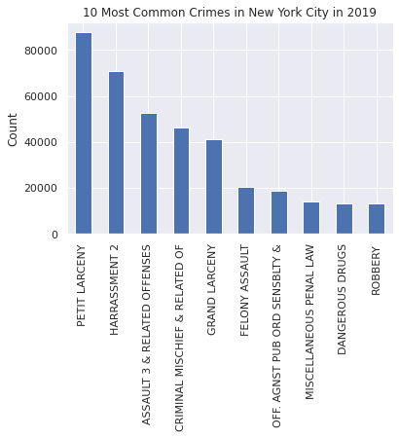

**Figure 4: Top 10 Crimes in New York in 2019**

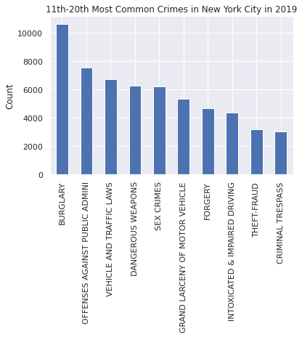

**Figure 5: 11-20 Most Common Crimes in New York in 2019**

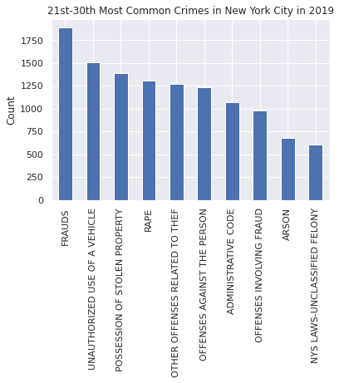

**Figure 6: 21-30 Most Common Crimes in New York in 2019**

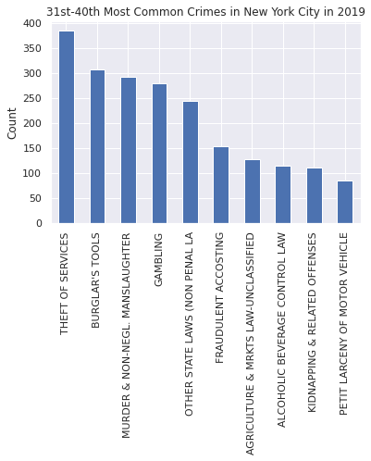

**Figure 7: 31-40 Most Common Crimes in New York in 2019**

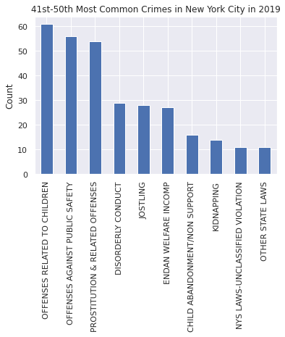

**Figure 8: 41-50 Most Common Crimes in New York in 2019**

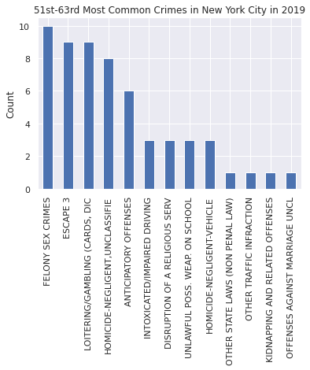

**Figure 9: 51-63 Most Common Crimes in New York in 2019**

The most common types of crimes committed seem to be larceny, harassment, assault, and criminal mischief. The least common types include offenses against marriage, kidnapping, and certain kinds of traffic infractions. The least common crimes seem to also include versions of more common types of crimes that couldn’t be fit in a different category or were more verbose in their descriptions. For example, petite larceny is listed as the most common type of crime in Figure 4, making it the most common type of crime committed in 2019. However, petite larceny of motor vehicle is listed as a different category and has sub 60 membership, making it one of the least common types of crimes committed.

**4. Methodology**

The methodology used for this project comprises the use of GMM-based algorithms over two separate approaches. The first approach is a supervised learning approach that endeavors to identify regions in New York city with varying amounts of violence. Violence class labels are identified from the data and are used as predictor variables for GMM models, with other attributes used for training purposes. For the second approach, interesting crime patterns in New York are first identified, based upon which GMM models are trained to find a spatial representation of these crimes and to also identify regions where certain types of crimes are likely to be committed. This is an unsupervised learning approach as the GMM is used to identify spatial clusters.

**4.1. Supervised learning approach using violence classification**

The violence classification approach is based on the idea that crimes can be divided in different classes of violence. A determination of the levels of violence and which crimes belong to which levels is required for this classification. The first step towards making this determination is to decide whether a particular crime included violence at all. If it did, then a follow-up decision regarding the level of violence needs to be made. For this study, these levels have been identified as Low Violence, Low to Medium Violence, Medium Violence, Medium to High Violence, and High Violence. A sixth class for crimes where violence is not determined to have been committed is also identified; this is named as the No Violence class. In the next step, three different general GMM are trained in order to classify crimes within the violence classes determined previously. Next, these models are used to predict the class to which the various crime incidents belong. These predictions are then used to demarcate the areas of violence within the city.

**4.1.1 Violence class label determination:** Based on the guidelines of the American Psychology Association (APA) [10], a determination of violence is made through the lens of the criminal act recorded. These guidelines help brings a level of objective reference for determining violence and create classes that would describe the nature of violence for each criminal incident.

In order to make this determination, the Key Code attribute is used as it assigns a category of crime to each complain in the dataset. The description of these categories is contained within the Offense Description attribute, which is instrumental in providing the context and extra information regarding how the Key Code values are interpreted. The various Offense Descriptions classified for violence are listed in Figures 10 and 11, which summarize the class determination decisions for the Offense Description labels.

Figure 10 shows a binary classification set, where crimes are divided between only two classes, namely Low Violence and High Violence. Figure 11 shows a multiclass classification set, including six classes in increasing order of violence, starting from No Violence and ending with High Violence. The first class is labeled No Violence, a class for crimes that have been determined to have involved low amounts of violence. The other classes include crimes for which a determination has been made that violence did occur. These classes are labeled Low Violence, Low to Medium Violence, Medium Violence, Medium to High Violence, and High Violence.

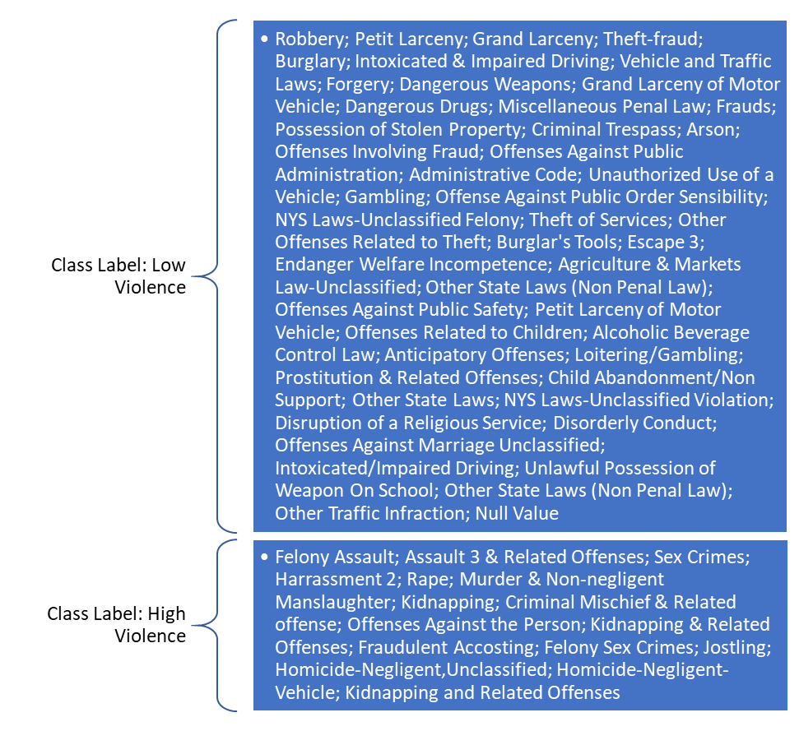

**Figure 10: Set I class labels based on offense description**

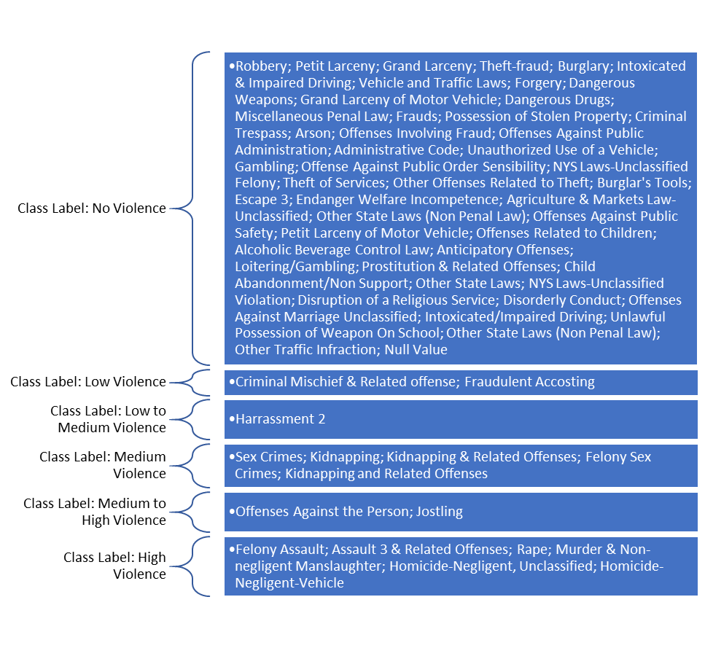**Figure 11: Set II class labels based on offense description**

A total of 63 labels have thus been classified manually, using the heuristics from the APA guidelines in [10], which completes the Offense Descriptions for the 63 Key Codes described in the dataset.

**4.1.2 Gaussian mixture models:** After the class labels are determined, three different GMM models with different attributes in the training data set are created.

A GMM is essentially a weighted sum of the densities of various Gaussian components as stipulated within continuous data vectors.

|  |  |
| --- | --- |
| . | (1) |

This is represented in equation (1), where $w_{i}, i=1,. . .,M,$ are the weights of the mixtures, while $g\left(x | µ_{i}\right), Σ_{i}), i=1,. . .,M$ are the densities of the Gaussian components. Here, $µ_{i}$ and $Σ_{i}$ are the mean vector and covariance matrix respectively. Along with the mixture weights $w_{i}$, these three values represent the parameters for the densities of each Gaussian mixture. Collectively, they parameterize the complete GMM and are represented by the notation in equation (2) [14].

|  |  |
| --- | --- |
| $$λ=\left\{w_{i},µ_{i}, Σ_{i}\right\}, i=1, . . . , M.$$ | (2) |

As can be seen from equation (1), the GMM method can be applied to numerical data only. This means that the kind of attributes that can be used as input for the GMM models must also be numerical. However, the New York Complaint dataset contains a lot of categorical attributes of interest. To use them in the GMM models, they are converted into one-hot vectors to allow computation through the GMM method. In each model, a different subset of these attributes is taken into consideration.

One-hot vectors are created by a process called one-hot encoding, where each unique non-numerical value in a feature is converted into a feature with only binary values, consisting of a series of 0s and 1s. Each vector thus created would have all low bit or 0 values, except in the case where it wants to indicate the applicable category label, for which a high bit or 1 would be used. This is the reason why these vectors are called one-hot. [15]

As the high bit is only used in the case of a particular category label being the true value, the overall size of each vector is, therefore, the total number of categories within a feature. Each position in the vector indicates whether the value is true or not for the category label that is represented by that position. Therefore, for each category label, a new feature or attribute needs to be added to the dataset. By using one-hot vectors for categorical features, as many features are added to the dataset as there are distinct values or labels within it.

Converting the several categorical features in such a fashion increased the total number of features used for training the three GMM models considerably. The total number of features used by the three models are summarized in Table 1. Table 1 also lists which set of classes from Figures 10 and 11 are used to train the models. These are the class labels that are supplied as the target variable in the algorithm.

**Table 1: GMM attributes across models for violence prediction**

|  |  |  |  |
| --- | --- | --- | --- |
| GMM Attributes | Model 1 | Model 2 | Model3 |
| Class Labels Set | Set II | Set I | Set I |
| Number of Features | 1066 | 1066 | 436 |
| Train/Test Split | 80/20 | 80/20 | 80/20 |
| Number of Mixture Components | 6 | 2 | 2 |
| Max EM Iterations | 100 | 100 | 100 |
| Number of Initializations | 1 | 1 | 1 |
| Initialization Method | kmeans | kmeans | kmeans |
| Covariance Type | Full | Full | Full |

In Table 1, the number of mixture components to find mirrors the number of classes in the set against which a particular model is trained. If the underlying components can be arranged well in a Gaussian distribution, then this assignment of classes will be represented in the outcomes. If not, then the outcomes will make it clear that the underlying class labels do not fall within well-defined and separable Gaussian distributions.

To best match the distribution of the feature vectors with a GMM configuration, it is important to find the best estimates for the parameters $λ$ of the GMM. The best parameters $λ$ are those that will maximize the likelihood of the GMM based on the feature vectors. The maximum likelihood (ML) estimation method is used for this purpose

ML estimation works by assigning the product of the likelihood of all feature vectors given a set of parameters $λ$ as the likelihood for the complete GMM. This is not a linear model and cannot be, therefore, directly maximized. [14]

To improve the ML estimation, therefore, an approach called expectation-maximization (EM) is used [16]. In this approach, a GMM model initialized with a set of parameters $λ$ is run iteratively to estimate new GMM models with improved parameters. The model parameters, namely the mixture weights $w_{i}$, means $µ_{i}$, and covariances $Σ_{i}$ are re-estimated following each EM iteration to ensure that the GMM likelihood always sees an increase [14]. The covariance matrix is essential to figure out the probability for a given mean and variance between the different elements within the Gaussian mixture component [17].

Therefore, to train the model to find the best GMM likelihood values, EM algorithms are run iteratively. These are set to 100 iterations for each model. Each model is initialized once, and the method used to do this is K-Means clustering. At the initialization step, weights are assigned based on the K-Means algorithm [1]. Each model is assigned full covariance, which implies that each mixture component has its own general covariance matrix. All of these model attributes are summarized in Table 1.

**4.1.3 Violence label predictions:** After the GMM described in Table 1 are trained and evaluated, they are used to reassign the violence labels for each record in the dataset.

Each crime incident in the entire dataset is assigned a label by predicting this value from the three GMM trained. In making this prediction, the labels for the classes are not provided to the model, which means that the model effectively learns the features when it was trained, and uses these learnings to assign the predictions.

Once these predictions are computed, these are added to the coordinates data to determine the location of each crime. Namely, the Latitude and Longitude attributes are used to help place these predictions on a map.

**4.2 Unsupervised learning approach using interesting crime patterns**

The use of GMM in the first approach of the methodology for this study is based on the premise that violence can be classified and that these classifications can be heuristically determined and be well-defined by Gaussian distributions. While this is a novel idea, it does not guarantee that the best Gaussian distributions are identified in the data. Considering this limitation of the first approach, a second approach is also applied to find meaning from data such that it can help demarcate crime regions in the city of New York.

It is evident from Figure 3 that the dataset is represented extremely densely in spatial representations laid over the city of New York. This is because the dataset is massive in size, with the number of crime complaints recorded equaling 461,711 in number. If an effort is made to find Gaussian distributions using all of this data, it is likely going to recommend one giant distribution covering the entirety of New York city.

Therefore, it is important to reduce the size of the data that can be analyzed using GMM. This can be accomplished by filtering the data based on certain conditions. In this case, the selection of the filtration criteria becomes a fundamentally important consideration as any subset of the data that is analyzed needs to be meaningful.

In order to find such meaningful data, exploration of categorical features is performed. Once interesting facts or patterns are discovered through such analysis, the datasets belonging to these facts and patterns are filtered-out. Then, an unsupervised algorithm based on GMM is trained over these filtered-out datasets to find spatially representative Gaussian clusters. Identification of such clusters can help demarcate crime regions in New York city for the kind of data described by the datasets.

**4.2.1. Data exploration to find interesting patterns:** The New York Complaint Map dataset contains several descriptive features that can be used to explain the data. It has attributes that can help determine the date, time, and location of a complaint. There also exist attributes that classify the complaints based upon the category of a crime as legally defined. The type of crimes can fall within umbrella categories, such as the three categories of felonies, violations, and misdemeanors, which are represented in the Law Category Code feature. They can also be part of a more granular level of categories, such as the 63 categories of the Key Code feature that were used for violence classification for the first approach. The exploration of these categories in terms of the frequency of crimes committed are listed in Figure 1 and Figures 4 through 9.

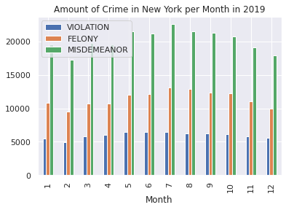

**Figure 12: Monthly Distribution of Crime by Law Category**

In an effort to find interesting facts in the data, a deeper dive of some of these frequency distributions is performed, as outlined in Figures 12, 13, and 14, where monthly, daily, and hourly frequencies of crime by law category are mapped respectively.

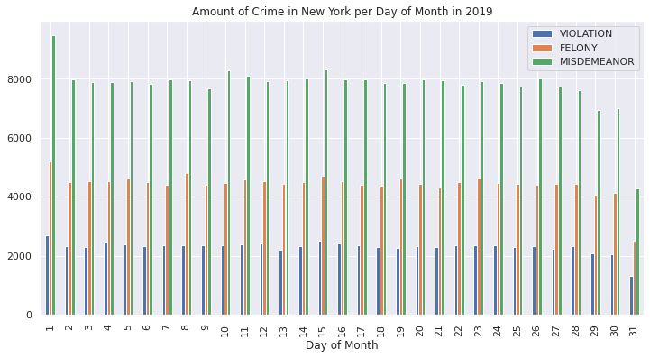

**Figure 13: Day of Month Distribution of Crime by Law Category**

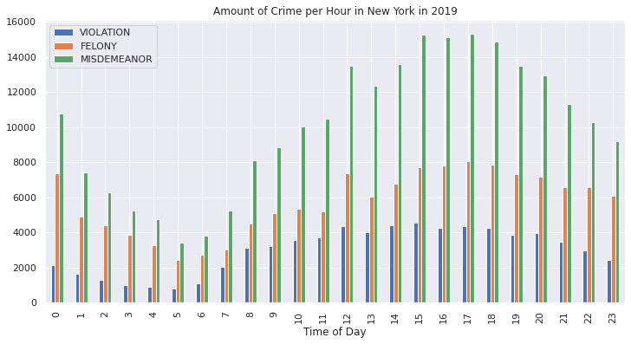

**Figure 14: Hourly Distribution of Crime by Law Category**

The overall outcome as observed in Figure 1 regarding the distribution of the crimes by law category is reaffirmed in Figures 12 through 14 for every observable month, day of month, and hour of day. For each granularity of time observed, misdemeanors are found to be the most common type of crime committed while violations are the least common.

One pattern that stands out is that the amount of crimes drops a lot at night time, as can be seen from Figure 14. However, this is not surprising considering that the level of activity in a city can also be presumed to drop significantly during the night time.

Another interesting observation is that the amount of overall crime for the 31st day in a month is considerably less - almost half as visually observed from Figure 13 – when compared with other days of the month. This can be explained by the fact that only 7 months out of 12 months have 31 days.

Further exploration is performed by analyzing four categories of crime, namely sex crimes, murder & non-negligent manslaughter, robbery, and dangerous drug crimes. An inspection of the hourly distribution of these crimes is performed, as charted out in Figure 15.

Figure 15 helps bring to light several patterns in crime that were previously not observed. For example, it is immediately apparent that far more sex crimes are reported at midnight as compared to other hours of the day. Another interesting pattern that emerges is that the highest frequency times for murder & non-negligent manslaughter category of crimes is at night between 9 pm and 2 am.

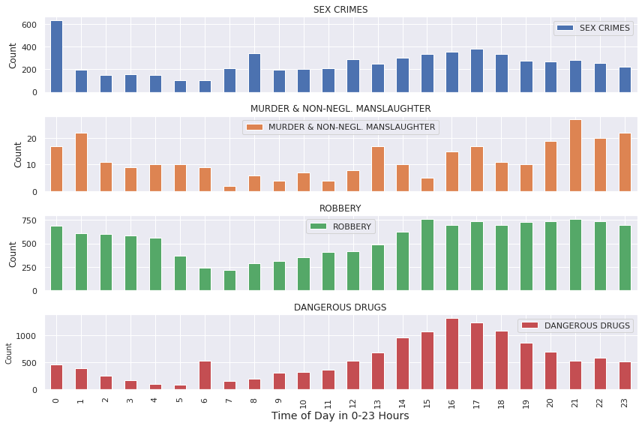

**Figure 15: Hourly Frequencies for Chosen Crimes**

While dangerous drug related crimes seem to peak at daytime, the frequency of such crimes reported at 6 am seems to be an anomaly as it is surrounded by low-frequency time-periods for dangerous drug related crimes. The 6 am observation is, therefore, a curious fact worthy of further analysis.

Other interesting observations regarding the data include the fact that disproportionately high percentages of drug-related crimes are related to either marijuana or sale of drugs.

Based on these observations, the dataset is divided into smaller sets, with each dataset representing an interesting pattern or fact discovered. The criteria for selection of the datasets is outlined in Table 2. Each of these datasets is to be processed separately for the GMM analysis outlined next.

**Table 2: Criteria for interesting datasets**

| Dataset Criteria | Number of Records |
| --- | --- |
| Sex Crimes at Midnight | 632 |
| Murder & Non-Negligent Manslaughter Crimes between 9 pm and 2 am | 108 |
| Dangerous Drug Crimes at 6 am | 533 |
| Marijuana Crimes | 1,838 |
| Drug Sale Crimes | 2,333 |

**4.2.2. Train Gaussian mixture models:** Considering that the GMM are to be trained over datasets that have already been determined to contain interesting, exploration worthy patterns, it is not required to keep categorical variables as part of the features that the GMM would train over. This is a marked difference from the first approach, where categorical labels were converted to numerical ones so they could be used in the GMM-based supervised learning algorithm.

Therefore, for each dataset, only the location data is used for training purposes. The location data is contained in the Longitude and Latitude attributes and is a genuine and reliable numerical representation of the spatial realities of the crimes. Considering this fact, it is a reasonable expectation that the outcomes of the GMM would show spatial Gaussian distributions, and any clustering observed within these distributions would be indicative of high crime regions for the particular category of crime analyzed.

The architecture of the unsupervised learning GMM-based algorithm shares certain similarities with the architecture of the supervised GMM-based algorithm used for violence classification. In both setups, the best parameters $λ$ are found by using ML estimation, which is maximized through 100 EM iterations [16]. The weights of the parameters are also initialized using the kmeans algorithm. Furthermore, each GMM model is assigned full covariance so that each Gaussian component would have its own full covariance matrix.

There are also important, discernable differences between the architectures of the two GMM-based algorithms. In the supervised algorithm, the number of Gaussian mixtures to find was fixed to the number of classes that needed to be predicted. However, in the usupervised algorithm, the number of mixture components is parameterized so that results for up to 100 Gaussian components can be analyzed. The model is trained recursively with increasing mixture component parameter values to get over 100 different GMM results for each dataset. This is done so that the best-fit model for each dataset can be found by comparing the results of many models.

To select the best model from the 100 models trained for each dataset, an analysis of the Akaike information criterion (AIC) and the Bayesian information criterion (BIC) is performed. As the likelihood of models increases by adding parameters and number of components, the risk of overfitting the data also increases. Both AIC and BIC attempt to dissuade overfitting by introducing penalty terms for the number of parameters in the model. [18, 19]

The penalty term for AIC is calculated using equation (3). BIC is calculated using a similar method; however, the penalty for BIC is much harsher, as shown in equation (4).

|  |  |
| --- | --- |
| $$AIC=2k-2ln⁡(L)$$ | (3) |
| $$BIC=kln(k)-2ln⁡(L)$$ | (4) |

In both equations (3) and (4), $k$ is the estimated number of parameters in the model and $L$ is the maximum value of the likelihood function of the model as determined after 100 EM iterations. The difference between AIC and BIC is that in AIC, the parameter $k$ is always multiplied by a constant 2, whereas in BIC the parameter $k$ is multiplied by the natural log of $k$, which will increase as $k$ increases. This difference leads to a higher penalty being applied as the overall BIC numbers will trend higher than the overall AIC numbers as the complexity of the model defined by the number of parameters increases. Keeping this in mind, lower AIC and BIC numbers are preferred for model selection. [18, 19]

**4.2.1. Visualize selected models:** The AIC and BIC numbers for the various GMM evaluated help determine the GMM with the best parameters for each dataset. These selected models need to be visualized in order to represent the learnings of the unsupervised model spatially.

For each Gaussian mixture component found by the algorithm, ellipses are used to represent the Gaussian clusters. The ellipses are centered on the mean value of the clusters, while the height and width of the ellipses are computed using the covariances. Four concentric ellipses are drawn for each cluster.

The clusters are also visualized on the map of New York city. For this visualization, however, ellipses are not used. The shape of the clusters is assigned by creating a polygon shape by joining each individual point in the cluster. The assignment of how the order in which points are picked is made at random.

**5. Results and discussion**

**5.1 Supervised learning GMM approach**

For the supervised learning GMM-based algorithm, classifications for violence are evaluated for accuracy of prediction of the test dataset. These results are encapsulated in Table 3. Based on these results, the best model has an accuracy of 50%, which belongs to Model 2. Model 1 has an accuracy of 18%, which is the worst accuracy out of the three models considered. However, it also has the higher log-likelihood score between itself and Model 2, which is an indicator of better fit as well outside of the accuracy. Model 3 should not be included in the comparison of log-likelihood scores as its training size was drastically smaller and it therefore had a smaller set of parameters. Since the log-likelihood scores are influenced by the number of parameters in the model, Model 3 cannot be used in this comparison.

**Table 3: Evaluation of GMM used for violence classification**

|  |  |  |  |
| --- | --- | --- | --- |
| Evaluation Criteria | Model 1 | Model 2 | Model 3 |
| Accuracy | 0.18 | 0.50 | 0.36 |
| Log-Likelihood Score | 5052.50 | 4448.48 | 1879.26 |

The predictions made by the three models have been geolocated on the map of New York city. Figure 16 shows the violence regions in New York city based on the predictions of Model 1. The placement of the points along the map shows clearly that the clusters identified by Model 1 based on the violence level class label predictions are also clustered together spatially. Although the visual representation shows a neat division of the violence regions in the city, it must be kept in mind that the predictions are only 18% accurate per the evaluation criteria in Table 4. Therefore, with this context in mind, it must be stated that this is not a reliable representation of the regions with violent crimes in New York. Model 1 seems to have done a good job of learning the spatial features in the dataset. The cluster assignment seems to be based upon the learnings of the location features. Since the prediction of violence zones in this model is based off only the location features, the model has a low accuracy score. The non-violent region is identified away from the downtown area, towards the Northern part of the city. It is surprising to see that the region identified as a high violence region is neighboring the one with no violence. Also, the low violence region is found to be far removed from the rest of the regions, with it being placed in the southern-most area of New York considered.

In Figure 17, the demarcation of the violence regions in New York city based on Model 2 are shown. Comparing the results in Figure 16 with Figure 17, it seems that both Model 1 and 2 pick the same areas as no violence regions, with Model 2 incorporating a larger area for this region as it identifies only two regions. In both models, the areas with lesser violence are identified to be in the northern parts of the city.

Model 2 suffers from the same problems as Model 1 in terms of its ability to classify violence regions. Figure 17 makes it clear that the spatial features are the dominant feature from which the model learns. Criminal activity as ascribed within the two clusters of low and high violence regions is spatially mutually exclusive.

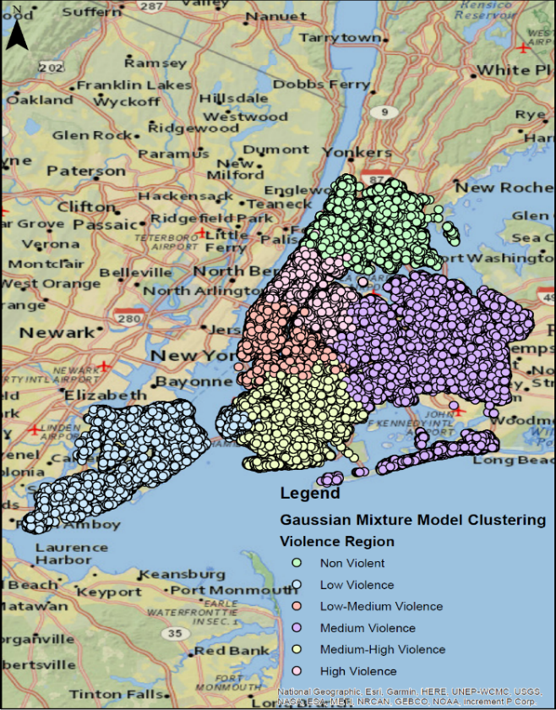

**Figure 16: Violence Regions in New York Based on Model 1**

Figure 18 depicts the predictions of Model 3 on the map of New York. Here, there are no apparent spatial clustering of the low violence or high violence regions. The instances seem to occur throughout the city without conforming to any identifiable clustering. However, unlike Model 1, Model 3 does not show that it learnt any spatial features. This is because, for this model, several spatially-related attributes were removed from the training dataset to reduce the training dataset size from over 1066 features to over 436 features.

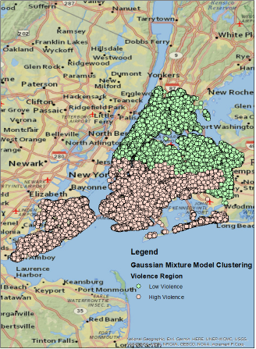

**Figure 17: Violence Regions in New York Based on Model 2**

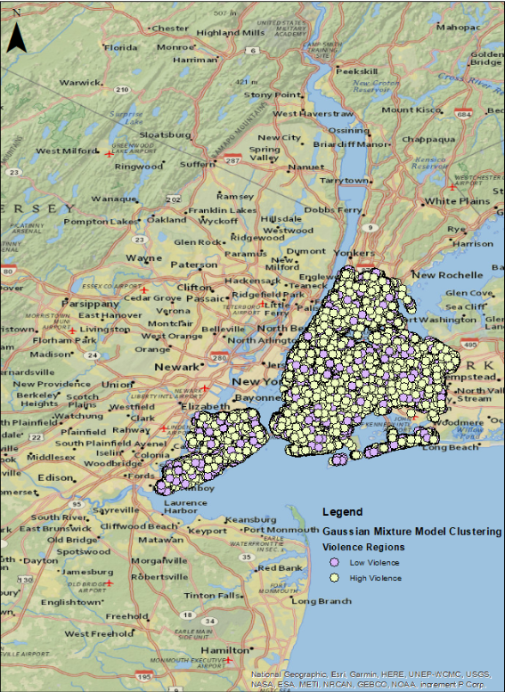

**Figure 18: Violence Regions in New York Based on Model 3**

Based on the results of Model 3, it is clear that the heuristics used for violence class determinations divided the dataset into classes that were spread throughout the city of New York without showing any spatial preference. Based on this evidence, it seems that further nuance in deciding the labels of violence is required to demarcate violence-based crime regions in New York.

**5.1 Unsupervised learning GMM approach**

For each dataset, the best GMM architecture is selected based on the AIC and BIC scores.

**5.1: Model selection for dataset with crimes related to sex:** Figure 19 shows theAIC andBICscores for the GMM trained over this dataset. It seems AIC and BIC are lowest when the GMM is trained with 76 Gaussian components. This model is chosen for visualization. However, a second model with only 3 Gaussian components is also selected for visualization as the number 76 is too high for clustering.

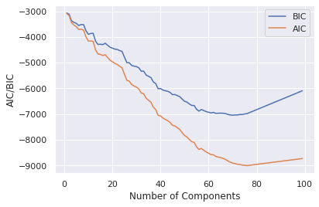

**Figure 19: AIC and BIC for sex crimes GMM**

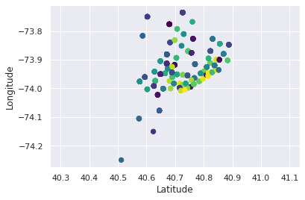

**Figure 20: Sex crime clustering with 76 Gaussian components**

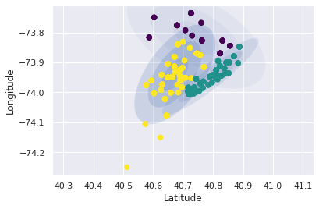

**Figure 21: Sex crime clustering with 3 Gaussian components**

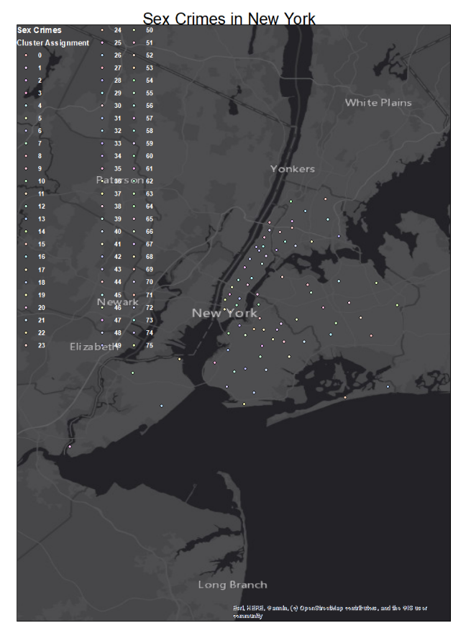

**Figure 22: Sex crime clustering with 76 clusters over New York**

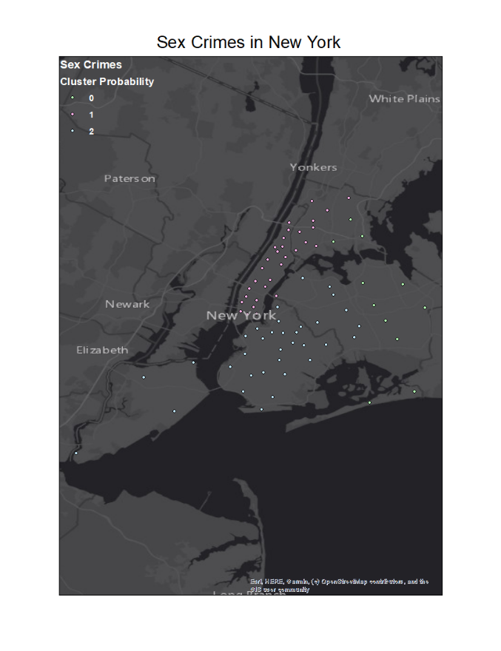

**Figure 23: Sex crime clustering with 3 clusters over New York**

Figures 20 and 21 show the spatial representation of the clusters including the concentric ellipse representation. The ellipses are not shown in Figure 20 because it contains too many clusters. It seems that the model with 3 clusters is a better indicator for defining cluster areas if overlapping of clusters is acceptable. Figures 22 and 23 show the cluster assignments for all the data points in this dataset, overlaid on the map of New York city. Finally, Figure 24 shows the 3-cluster model with cluster shapes determined by joining the data points to create a polygon. Figure 24 shows a good visual representation of the regions in New York where sex crimes at midnight are reported. Unlike the 3-ellipse model in Figure 21, it does not show any overlap among the cluster regions. Furthermore, the membership of the clusters is represented by the line connections between the individual points within the cluster, as shown in Figure 24. This helps give a visual representation of the density of the clusters.

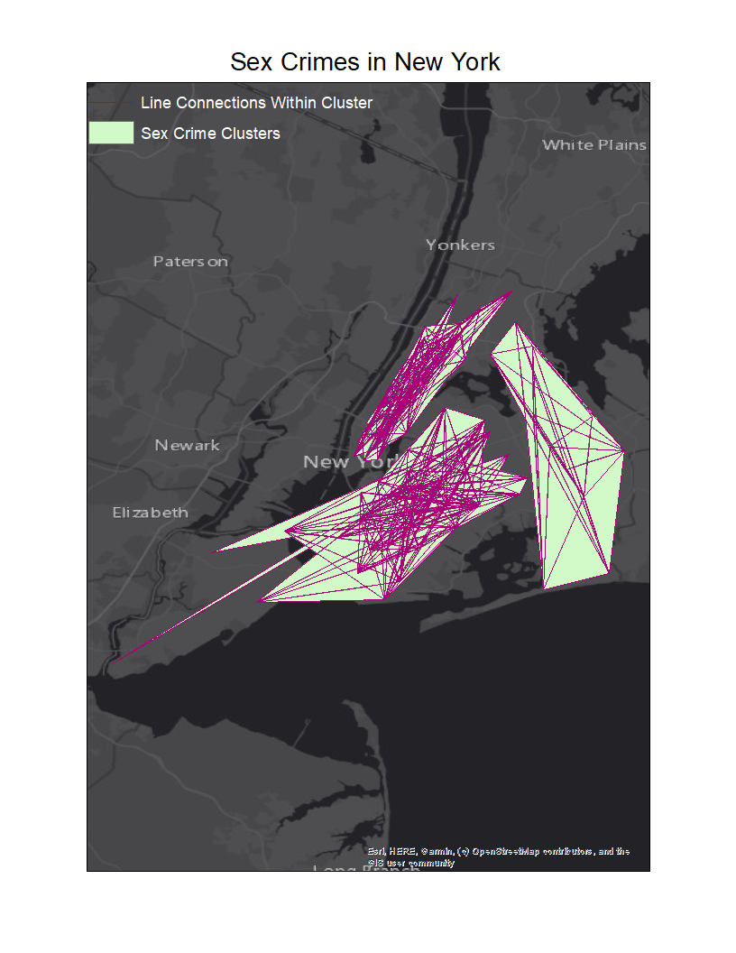

**Figure 24: Sex crime clustering with 3 clusters in New York**

**5.2: Model selection for dataset with crimes related to murder and non-negligent manslaughter:** Figure 25 shows theAIC andBICscores for the GMM trained over this dataset. It can be seen that AIC keeps reducing over increasing parameter size until it reaches a model with 21 clusters, while BIC is lowest for the model with only 4 clusters. Therefore, both the 21 and 4 cluster models are chosen for visualization as the best models.

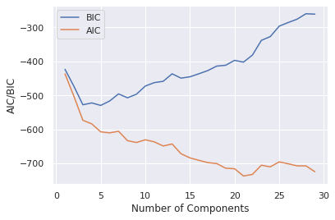

**Figure 25: AIC and BIC for murder and non-negligent manslaughter crimes GMM**

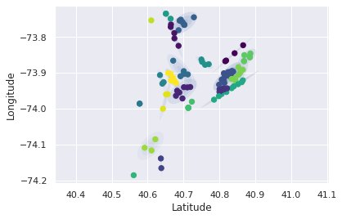

**Figure 26: Murder crime clustering with 21 clusters**

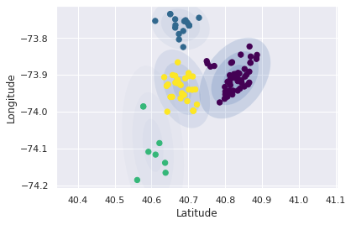

**Figure 27: Murder crime clustering with 4 clusters**

The elliptical cluster visualizations for these models are shown in Figures 26 and 27. It can be observed that the clusters in Figure 26 are closer together and more numerous, whereas those in Figure 27 are bigger in size. 2 out of 4 clusters are spatially separate, while 2 other clusters show a slight overlap over the fourth concentric ellipse.

Figures 28 and 29 show the point-wise distribution of these cluster assignments on the map of New York, while Figures 30 and 31 also show the polygon cluster shapes. These figures make it clear that the clusters identified are consistently separately identifiable and self-contained with little overlap between clusters. These clusters are a good example for identifying the regions where murder and non-negligent manslaughter type of crimes are committed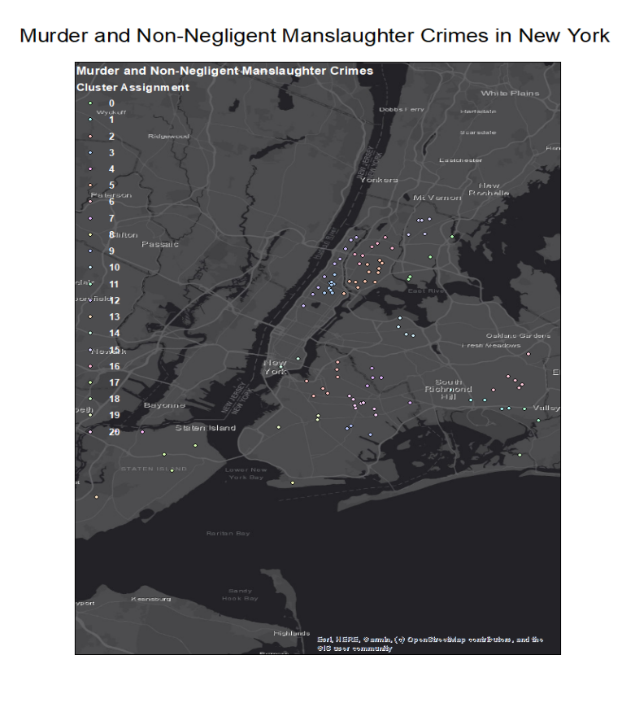

**Figure 28: Murder crime clustering with 21 clusters in New York**

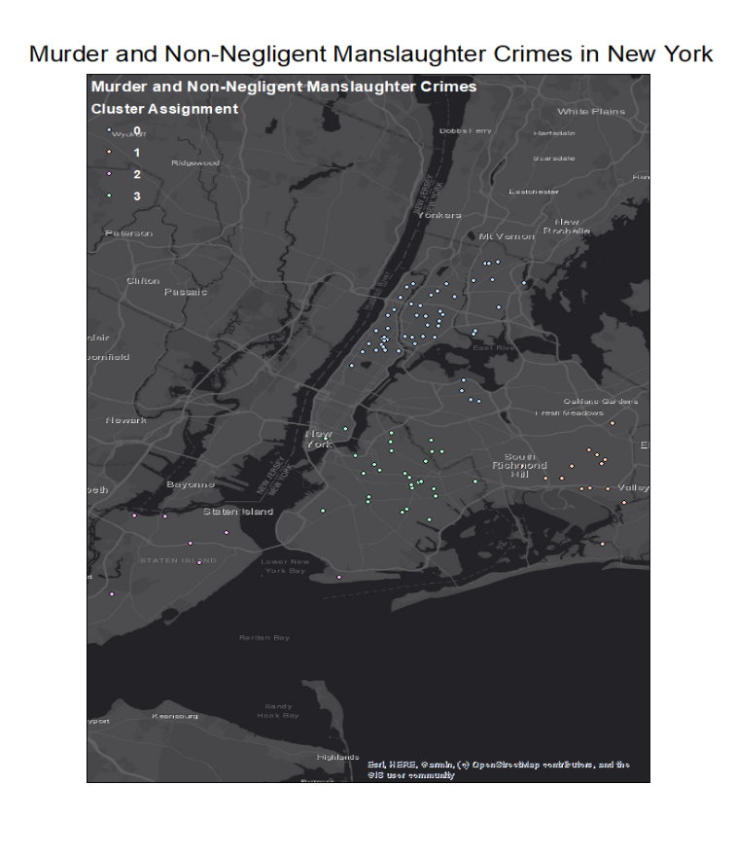

**Figure 29: Murder crime clustering with 4 clusters in New York**

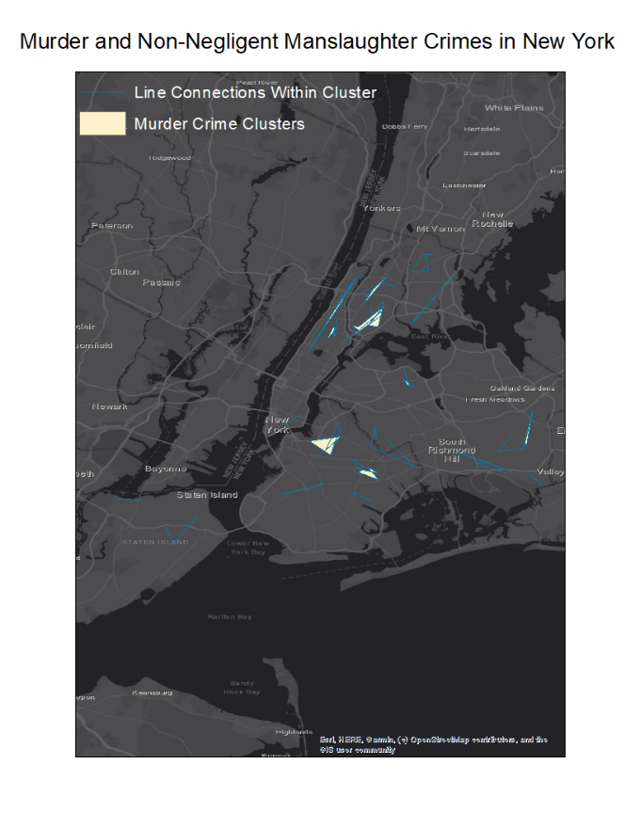

**Figure 30: Murder crime clustering with 21 clusters in New York**

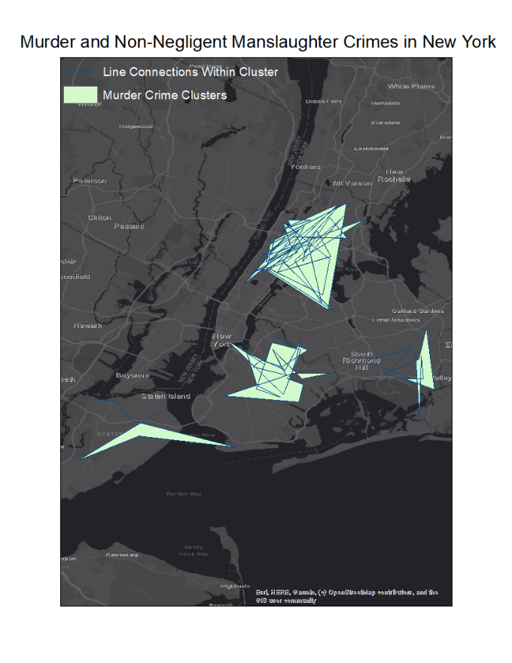

**Figure 31: Murder crime clustering with 4 clusters in New York**

**5.3: Model selection for dataset with crimes related to marijuana:** Figure 32 shows theAIC andBICscores for the GMM trained over this dataset. It seems AIC and BIC are lowest when the GMM is trained with 24 Gaussian components. This model has been chosen for visualization. However, a second model with only 3 Gaussian components is also selected as a good model to reduce the number of clusters. It seems that as the models are trained, there’s a steep drop in AIC and BIC numbers. This steep drop ends at the model defined with 4 clusters, which is why this model is also chosen for visualization.

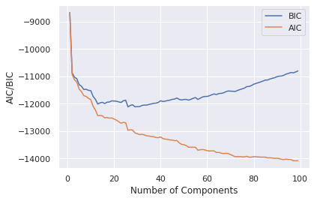

**Figure 32: AIC and BIC for marijuana related crimes GMM**

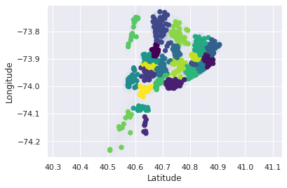

**Figure 33: Marijuana crime clustering with 24 clusters**

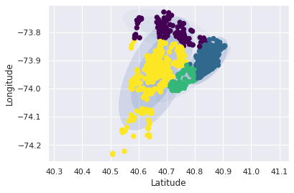

**Figure 34: Marijuana crime clustering with 4 clusters**

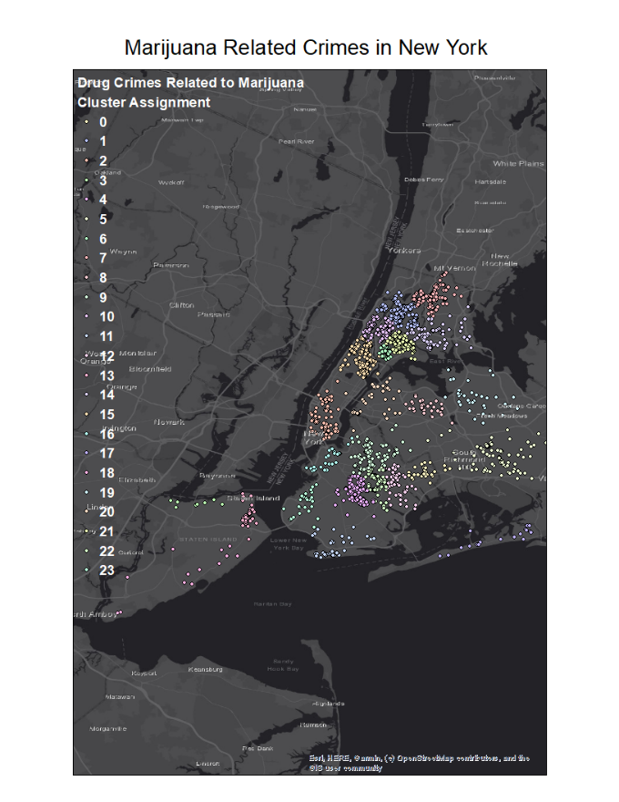

**Figure 35: Marijuana crime clustering with 24 clusters in New York**

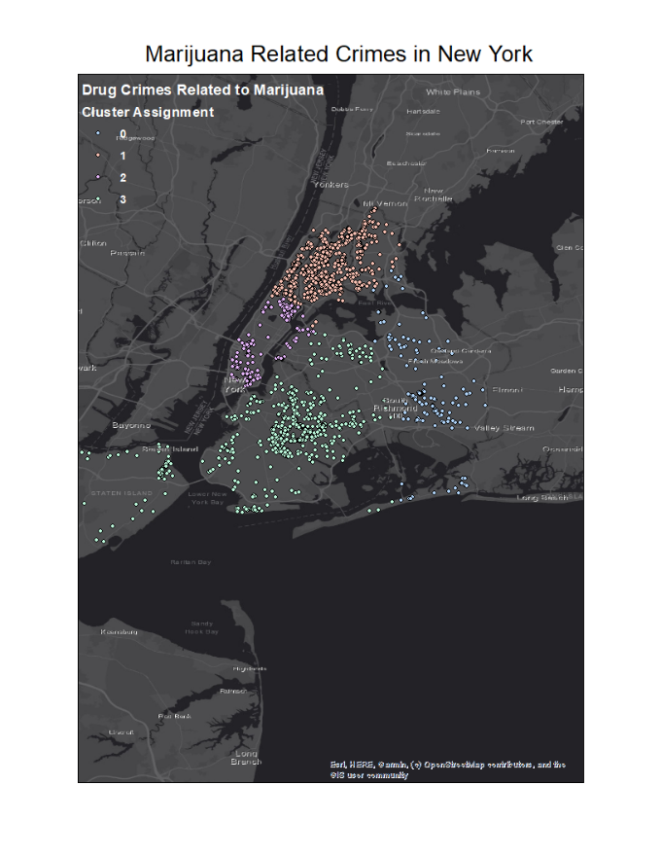

**Figure 36: : Marijuana crime clustering with 4 clusters in New York**

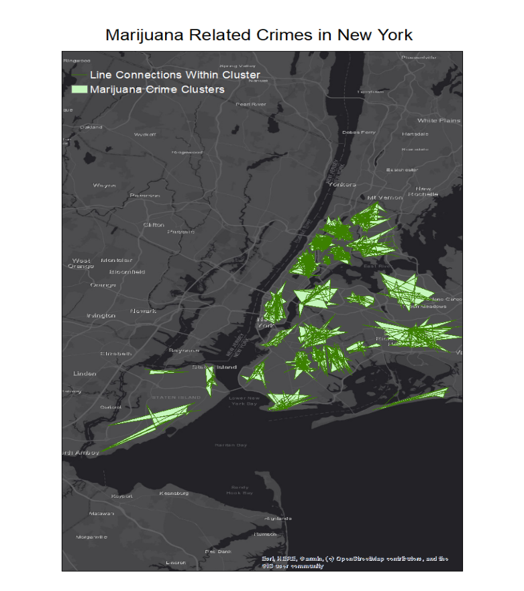

**Figure 37: Marijuana crime clustering with 24 clusters in New York**

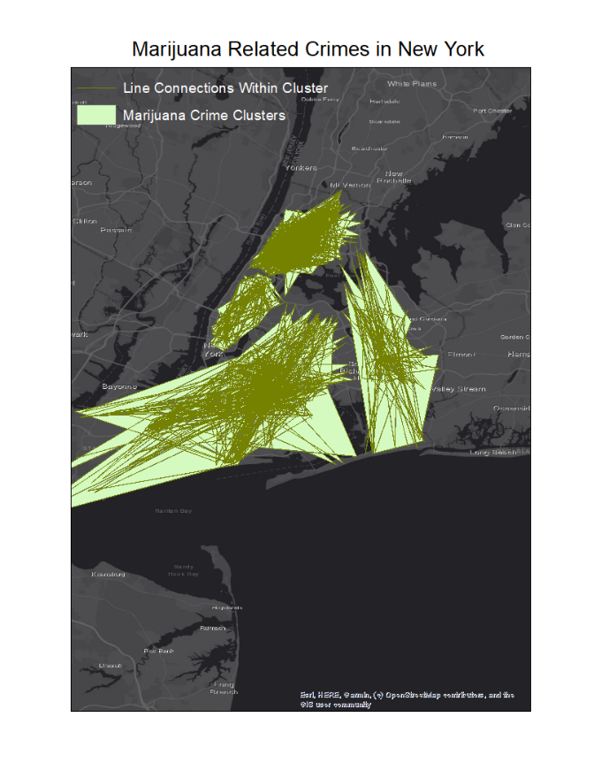

**Figure 38: Marijuana crime clustering with 4 clusters in New York**

Figures 33 and 34 show the spatial representation of the clusters including the concentric ellipse representation. The ellipses are not easily visible in Figure 33, which is an indication that the 24-cluster model has very small clusters. The model with 4 clusters shown in Figure 34 has larger clusters; however, it is dominated by 1 large cluster and 3 comparatively smaller clusters. The clusters are also shown to be closer together, which indicates that all marijuana related crimes are spread across a large area of New York city.

Figures 35 and 36 show the cluster assignments for all the data points in this dataset, overlaid on the map of New York city. These figures make it clear that marijuana related crimes are spread throughout the five boroughs in New York.

Figures 37 and 38 show the 24 cluster and 4 cluster models with the clusters assigned polygon shapes. Unlike Figure 33, where it seemed that the clusters were too small and close together, Figure 37 shows that when the same clusters are overlaid on the map of New York city, they seem to be more well-defined and do not overlap with other clusters. The clustering shown in Figure 38 seems to mimic the problems observed with the clustering in Figure 34.

Based on this analysis, it seems the model with 24 clusters, best shown in Figure 37, is the best model to demarcate regions of crime related to marijuana in New York city.

**5.4: Model selection for dataset with crimes related to drug sales:** Figure 39 shows theAIC andBICscores for the GMM trained over this dataset. It seems AIC and BIC are lowest when the GMM is trained with 35 Gaussian components. This model has been chosen for visualization.

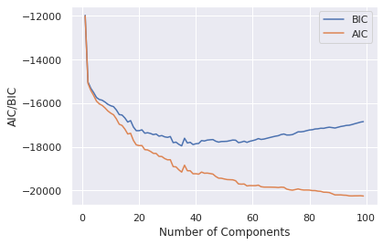

**Figure 39: AIC and BIC for sales related drug crimes GMM**

However, a second model with only 6 Gaussian components is also selected as a good model to reduce the number of clusters. As the models are trained, there’s a steep drop in AIC and BIC numbers, which ends as the model reaches with 6 clusters is defined. This behavior mimics that observed for the marijuana crime dataset as well.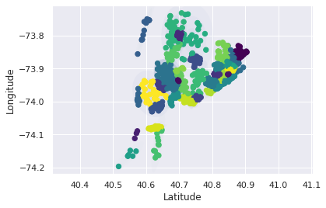

**Figure 40: Drug sale crime clustering with 35 clusters**

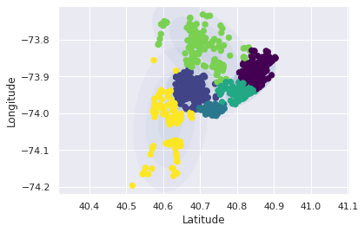

**Figure 41: Drug sale crime clustering with 6 clusters**

Figures 40 and 41 show the spatial representation of the clusters including the concentric ellipse representation. The ellipses are not easily visible in Figure 40, which is an indication that the 35-cluster model has small clusters. The model with 6 clusters shown in Figure 41 has larger clusters and is dominated by 1 large cluster. The depiction of the clusters and the overall shape of where the crimes are located mimics that observed for the marijuana dataset. This is expected since both the datasets are dealing with drug related crimes.

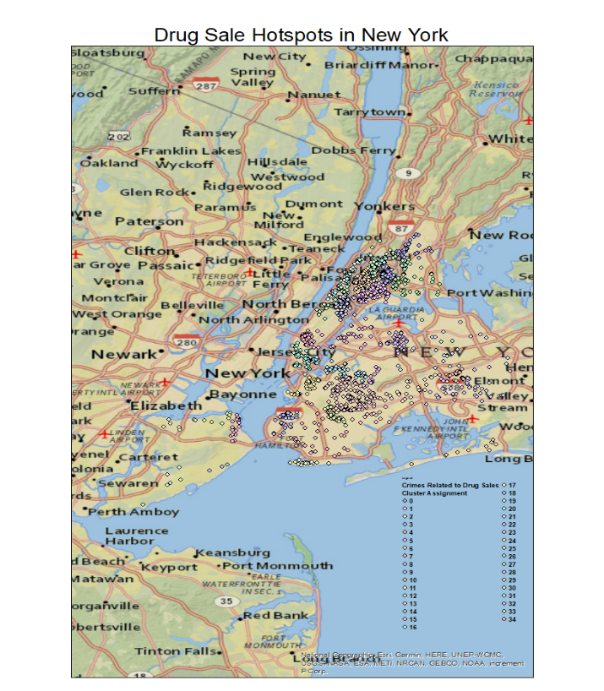

**Figure 42: Drug sale crime clustering with 35 clusters in New York**

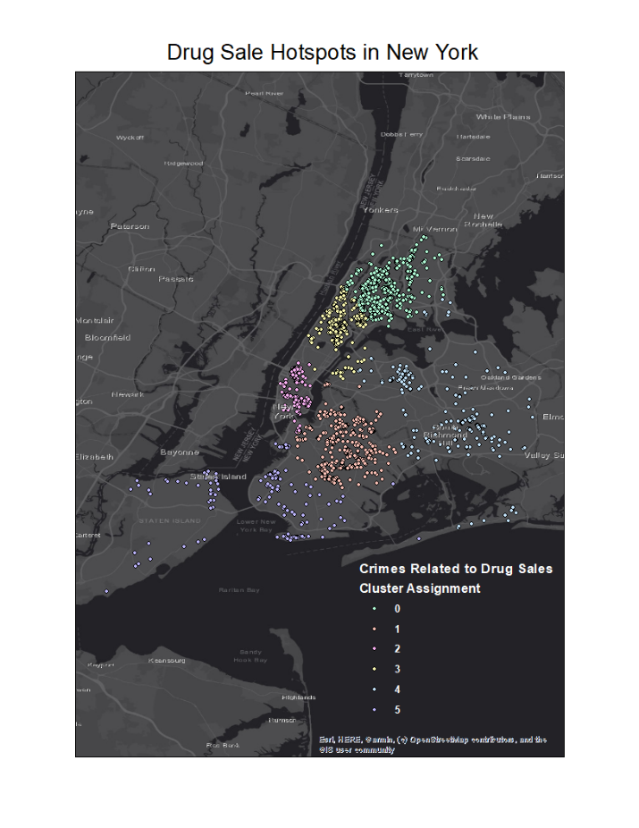

**Figure 43: Drug sale crime clustering with 6 clusters in New York**

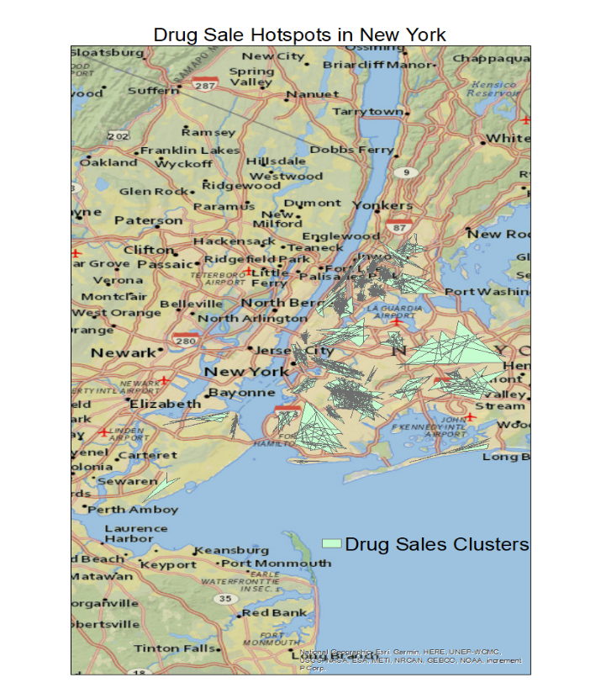

**Figure 44: Drug sale crime clustering with 35 clusters in New York**

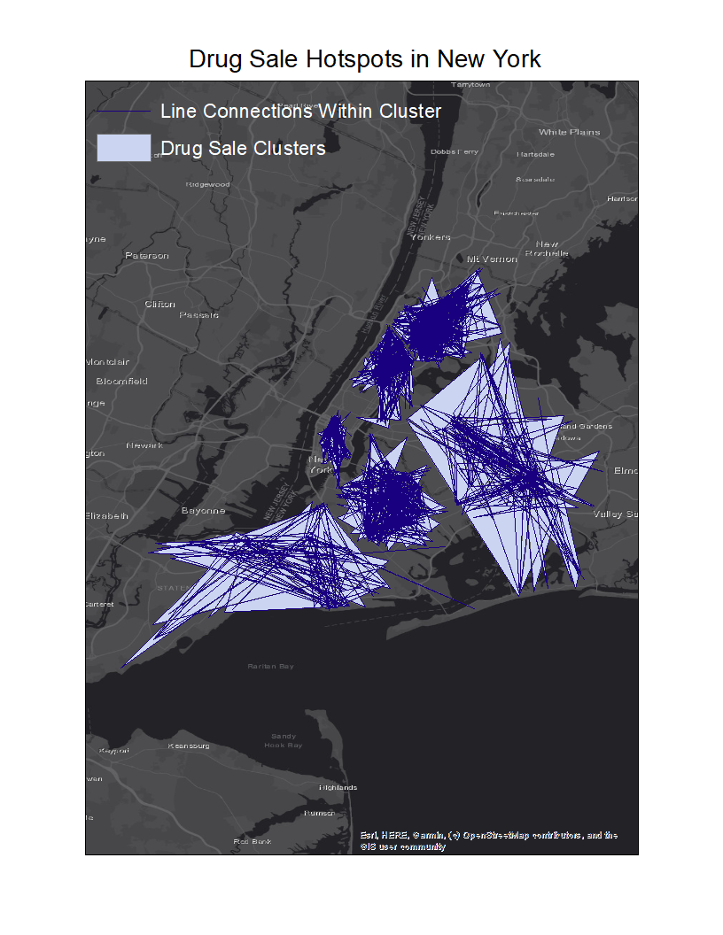

**Figure 45: Drug sale crime clustering with 6 clusters in New York**

Figures 42 and 43 show the cluster assignments for all the data points in this dataset, overlaid on the map of New York city. These figures make it clear that drug sales related crimes are spread throughout the five boroughs in New York. However, there are pockets with high density of crimes.

An attempt to capture these pockets of crime is made in Figures 44 and 45. They show the 35-cluster and 6-cluster models with the clusters assigned polygon shapes. Figure 44 resolves some of the problems observed with Figure 40 as the clusters that previously seemed too small and close together are shown to be well spread out and be spatially independent of other clusters. The clustering shown in Figure 45 also seems to improve upon the spatial independence of clusters that was not well-defined in Figure 41.

Based on this analysis, it seems the model with 35 clusters, best shown in Figure 44, is the best model to demarcate regions of crime related to drug sales in New York city.

**5.5: Model selection for dataset with crimes related to drugs:** Figure 46 shows theAIC andBICscores for the GMM trained over this dataset. As the number of Gaussian components increase, AIC and BIC show a steep fall that ends with the model defined with 4 clusters. After this point, BIC starts rising rapidly, indicating that the penalties with selecting a more complex model would be much harsher than observed in the case of drug crimes related to marijuana and sales. AIC, on the other hand, shows a gentle decline. The AIC number doesn’t show steep decline (or rise, for that matter) for the models where BIC increases steeply. Therefore, only the model where both AIC and BIC ended their steep decline, before BIC started rising again, is chosen as the model with the best parameters. This is the 4-cluster model

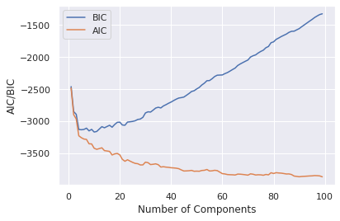

**Figure 46: AIC and BIC for drug crimes GMM**

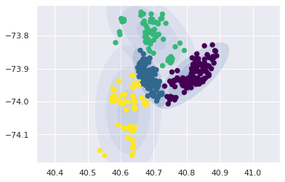

**Figure 47: Drug related crimes clustering with 4 clusters**

Figure 47 shows the spatial representation of the clusters including the concentric ellipse representation. While mostly spatially independent, the clusters do show some degree of overlap. The shapes of all the clusters combined together mimics that observed in the case of marijuana and drug sale related clusters. This is along the expected lines as all three analysis have the same main category of crime, namely dangerous drugs.

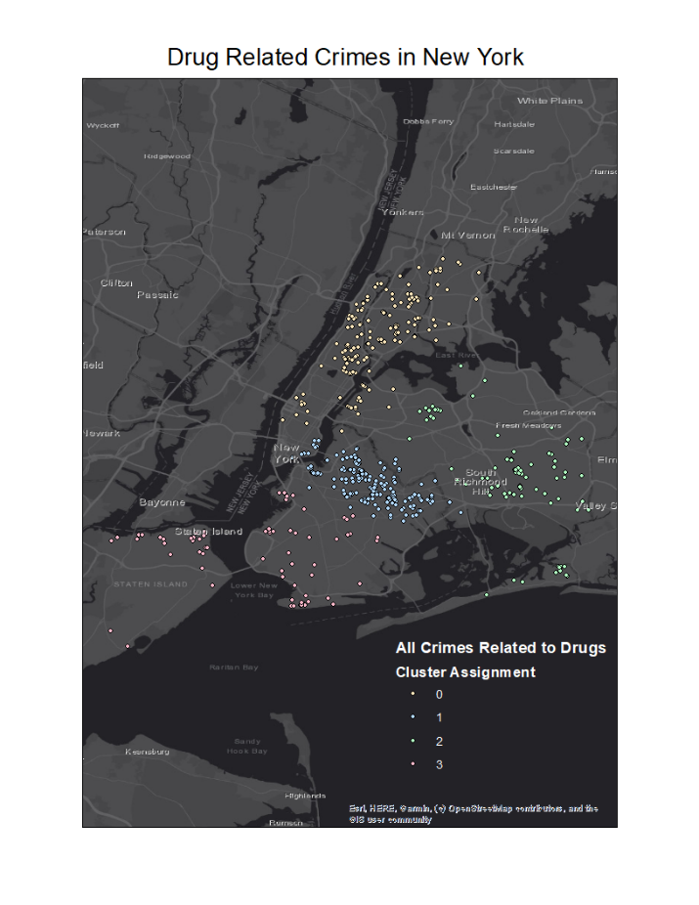

**Figure 48: Drug related crimes clustering with 4 clusters in New York**

Figure 48 shows the cluster assignments for all the data points in this dataset, overlaid on the map of New York city. This depiction makes it clear that crimes related to drug are spread throughout the five boroughs in New York. However, there are pockets with high density of crimes. Staten Island stands out as the borough with the lowest occurrence of such crimes.

Figure 49 attempts to capture the pockets of crime observed in Figure 48. Here, the clusters are assigned polygon shapes. It is clear that Brooklyn is the region with the highest density of drug related crimes in New York city.

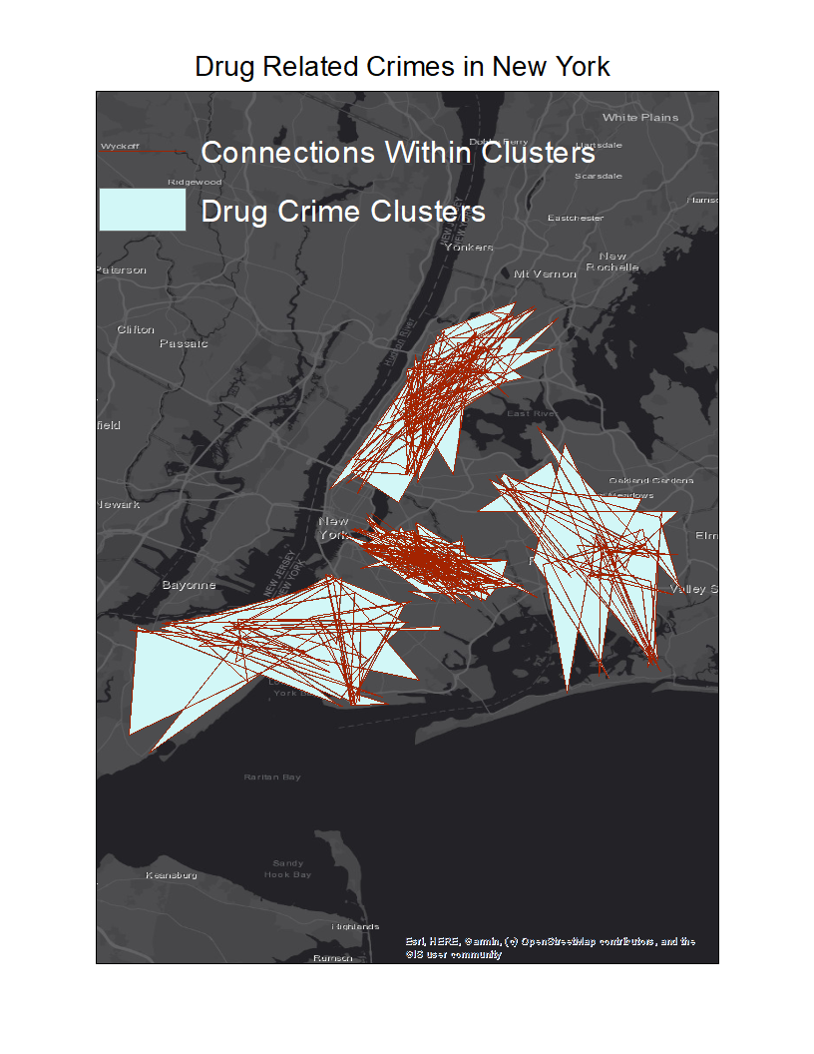

**Figure 49: Drug related crime clustering with 4 clusters in New York**

**6. Conclusions and future directions**

For the supervised learning GMM algorithm that classifies violence, it seems that Model 2 performs best at 50% accuracy. Models 1 and 2 were able to learn the spatial features from the data; however, they were unsuccessful in predicting the violence regions appropriately.

The class labels for violence were based on the Key Code attribute and description. These labels were inferred from the Offense Description attribute. 48 out of the 63 labels assigned were low violence labels, which means that there were very few positive data points for the model to learn from. This could be a reason as to why the GMM had a low accuracy rate.

Another reason could be that the violence labels as determined through the heuristics described above are distributed randomly across New York city. This means that any Gaussian classification would lead to large clusters spread across the city. Such clustering is ineffectual as it may overlap with other clusters spatially. This case was observed in Model 3 where spatial features were not provided to the algorithm.

In future studies, novel ideas for determining these violence labels could be tried to improve the accuracy rates. While the visualizations are not representative of accurate predictions of violence, they do introduce the concept of being able to demarcate a city’s map into regions based on violence, which could be a valuable resource for future research and analysis in this field.

For the unsupervised learning GMM algorithm, the best models for the various types of crimes were able to define pockets or regions of the selected types of crime with a lot more clarity. The best representations of the crime regions in New York city were those where clusters learned from the GMM algorithm were laid over the map of New York city and shaped into polygons by joining the data points within each cluster. Little to no overlap between clusters was observed this way and the density of the clusters was also immediately apparent, providing another metric to assess the depicted crime regions.

This approach is promising and can be used to demarcate other types of crimes in New York as well as in other cities for which crime-related data can be obtained. By finding interesting patterns of crime first, the unsupervised GMM algorithm is able to provide meaningful spatial clusters that can be used to demarcate crime regions in urban areas.

**7. References**

|  |  |
| --- | --- |
| [1] | "Gaussian Mixture Models," [Online]. Available: https://scikit-learn.org/stable/modules/mixture.html. [Accessed 01 April 2020]. |
| [2] | *Data-Driven Spatio-Temporal Analysis of Curbside Parking Demand: A Case-Study in Seattle,* 2017. |
| [3] | Y. Qi, H. Li, Y. Wang and B. Liu, "Spinning tri-layer-circle memory-based Gaussian mixture model for background modeling," Chengdu, 2016. |
| [4] | R. Fan, R. Huang and R. Diao, "Gaussian Mixture Model-Based Ensemble Kalman Filter for Machine Parameter Calibration," *IEEE Transactions on Energy Conversion,* vol. 33, no. 3, pp. 1597-1599, 2018. |
| [5] | C.-M. Hsu, F.-L. Lian and C.-M. Huang, "A Systematic Spatiotemporal Modeling Framework for Characterizing Traffic Dynamics Using Hierarchical Gaussian Mixture Modeling and Entropy Analysis," *IEEE Systems Journal,* vol. 8, no. 4, pp. 1129-1138, 2014. |
| [6] | L. Yu, T. Yang and A. B. Chan, "Density-Preserving Hierarchical EM Algorithm: Simplifying Gaussian Mixture Models for Approximate Inference," *IEEE Transactions on Pattern Analysis and Machine Intelligence,* vol. 41, no. 6, pp. 1323-1337, 2019. |
| [7] | J. Zhu, Z. Ge and Z. Song, "Variational Bayesian Gaussian Mixture Regression for Soft Sensing Key Variables in Non-Gaussian Industrial Processes," *IEEE Transactions on Control Systems Technology,* vol. 25, no. 3, pp. 1092-1099, 2017. |
| [8] | M. Niknejad, H. Rabbani and M. Babaie-Zadeh, "Image Restoration Using Gaussian Mixture Models With Spatially Constrained Patch Clustering," *IEEE Transactions on Image Processing,* vol. 24, no. 11, pp. 3624-3636, 2015. |
| [9] | E. R. P. Altafim and M. B. M. Linhares, "Universal violence and child maltreatment prevention programs for parents: A systematic review," *Psychological Intervention,* vol. 25, no. 1, pp. 27-38, 2016. |
| [10] | A. E. Kazdin, Encyclopedia of Psychology, American Psychology Association, 1946. |
| [11] | S. Subramani, S. Michalska, H. Wang, J. Du, Y. Zhang and H. Shakeel, "Deep Learning for Multi-Class Identification From Domestic Violence Online Posts," *IEEE Access,* vol. 7, pp. 46210-46224, 2019. |
| [12] | M. Ramzan, A. Abid, H. U. Khan, S. M. Awan, A. Ismail, M. Ahmed, M. Ilyas and A. Mahmood, "A Review on State-of-the-Art Violence Detection Techniques," *IEEE Access,* vol. 7, pp. 107560-107575, 2019. |
| [13] | "NYPD Complaint Map (Year to Date)," NYC Open Data, [Online]. Available: https://data.cityofnewyork.us/Public-Safety/NYPD-Complaint-Map-Year-to-Date-/2fra-mtpn. [Accessed 23 March 2020]. |
| [14] | D. A. Reynolds, "Gaussian Mixture Models," [Online]. Available: http://leap.ee.iisc.ac.in/sriram/teaching/MLSP_16/refs/GMM_Tutorial_Reynolds.pdf. [Accessed 30 November 2020]. |
| [15] | L. Yuanqing, Y. Suying, X. Jiangtao and G. Jing, "A Self-Checking Approach for SEU/MBUs-Hardened FSMs Design Based on the Replication of One-Hot Code," *IEEE Transactions on Nuclear Science,* vol. 59, no. 5, pp. 2572-2579, 2012. |
| [16] | K. Yu, X. Dang, H. Bart and Y. Chen, "Robust Model-Based Learning via Spatial-EM Algorithm," *IEEE Transactions on Knowledge and Data Engineering,* vol. 27, no. 6, pp. 1670-1682, 2015. |
| [17] | S. Ambikasaran, D. Foreman-Mackey, L. Greengard, D. W. Hogg and M. O'Neil, "Fast Direct Methods for Gaussian Processes," *IEEE Transactions on Pattern Analysis and Machine Intelligence,* vol. 38, no. 2, pp. 252-265, 2016. |
| [18] | G. Schwarz, "Estimating the Dimension of a Model," *Annals of Statistics,* vol. 6, no. 2, pp. 461-464, 1978. |
| [19] | H. Akaike, "A new look at the statistical model identification," *IEEE Transactions on Automatic Control,* vol. 19, no. 6, pp. 716-723, 1974. |